Name Student ID

Whelk noodle salad

Ingredients
1/2 onion or green onion of your choice
1 cucumber
1/2 carrot
1 can of whelk
Sauce
Noodle

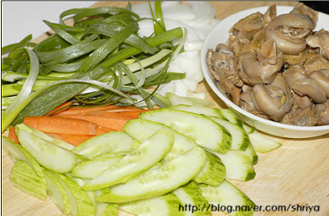 1) Cut vegetables in long stick-shaped sizes.
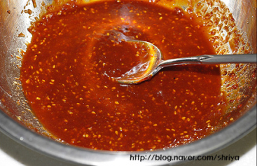 2) Prepare salad dressing with a little bit of juice from the can of whelk and add spicy sauce. Stir well.
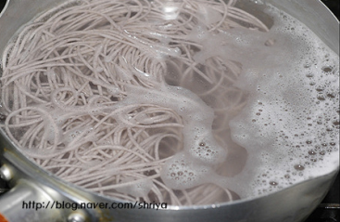 3) Cook noodles in a large pot of boiling salted water until just tender. Drain in a colander and rinse under cold water until cool.
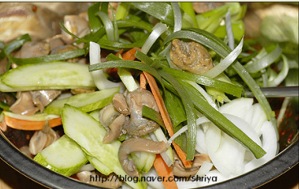 3) In a large bowl, mix together all the ingredients except for the noodles. Stir in some sauce until it tastes a bit strong.
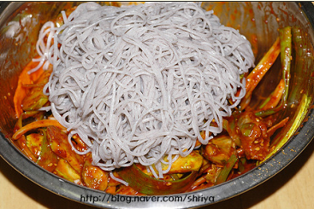 4) Cover the well mixed ingredients with cooked noodles. Mix well.
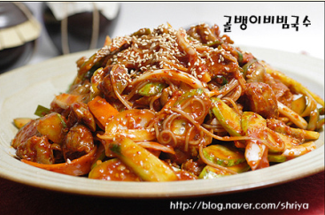 5) Serve at room-temperature or chilled.

