Describing physical appearance

Height
 |  |  | 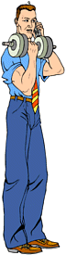 |  |  |  |  |  |  |  |  |  | 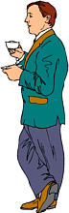 |  |  |  |  |  |  |  |  |  |  | 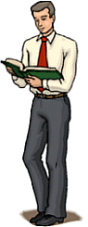
 |  |  | He is tall. |  |  |  |  |  |  |  |  |  | He is short. |  |  |  |  |  |  |  |  |  |  | He is medium-height.

Build
 |  |  |  |  |  |  |  |  |  |  |  |  |  |  |  |  |  |  | 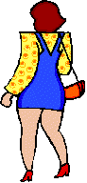
She is skinny. (negative) |  |  |  |  |  |  |  |  |  |  |  |  |  |  |  |  |  |  | She is fat. (negative)
She is underweight. (negative) |  |  |  |  |  |  |  |  |  |  |  |  |  |  |  |  |  |  | She is overweight. (negative)
She is thin. (negative) |  |  |  |  |  |  |  |  |  |  |  |  |  |  |  |  |  |  | She is plump. (neutral)
She is slim. (positive) |  |  |  |  |  |  |  |  |  |  |  |  |  |  |  |  |  |  | She is stocky. (neutral)
She is slender. (positive) |  |  |  |  |  |  |  |  |  |  |  |  |  |  |  |  |  |  | She is bonny. (positive) ^
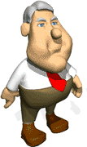
If a man is fat (especially round the waist),
we often say he has a beer belly.

Eyes
 |  | 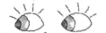
 |  | grey eyes |  |  |  |  |  | green eyes |  |  |  |  |  |  | blue eyes |  |  |  |  |  | brown eyes |  |  |  |  | dark eyes
 |  | 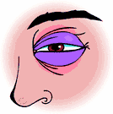 |  |  |  |  |  | This is a black eye!

Type of hair
 | 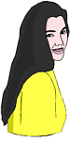 |  |  | 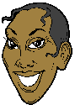 |  |  |  |  |  | 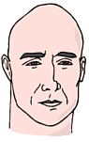 |  |  |  |  |  |  | 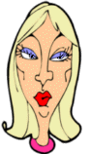 |  |  |  |  | 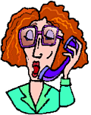 |  |  |  |  |  |  |  | 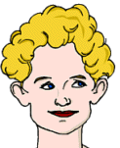
 | She has long, straight, black hair. |  |  | She has short, straight, black hair. |  |  |  |  |  | He has no hair. = He is bald. |  |  |  |  |  |  | She has medium length, straight, blonde hair. |  |  |  |  | She has medium length, wavy, red hair. |  |  |  |  |  |  |  | She has short, curly, blonde hair.

Type of complexion
He is asian. He has light-brown skin. |  |  |  |  |  |  | She is black. She has dark skin. |  |  |  |  |  |  | He is white. He has fair skin. |  |  |  |  |  | She is white.  She has lightly tanned skin. |  |  |  |  |  |  | She is white. She has very pale skin.

Other features
 | 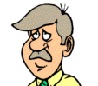 |  |  |  | 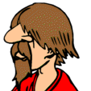 |  |  |  |  |  |  |  |  |  |  |  |  |  |  |  |  |  |  |  |  |  |  |  | 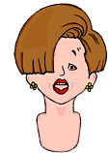
 | moustache |  |  |  |  | beard |  |  |  |  |  | chin |  |  |  | forehead |  |  |  |  |  |  |  |  | nostrils |  |  |  |  | fringe

*These words describe physical appearance. Add them to the table below.
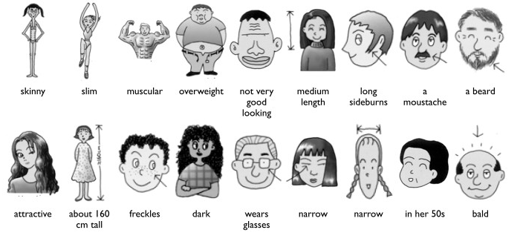

Words that describe physical appearance
Height | Short average height tall
Build | Small average build well-built
Age | Around 25 in his 30s middle-aged elderly
Hair | Short long  Straight wavy curly a ponytail  White grey blond light/dark brown red black
Face | Square round plain wide thin
Complexion | Fair white
Eyes | Green blue brown black big  Wear contact lens
General | Beautiful pretty handsome sexy cute good looking

*Read the descriptions. What are the missing words? Write is or has. Then match the descriptions with the pictures below.
A she is around 20. She is tall, slim and beautiful. She has long straight black hair.

B He ________ average height and average build. He ________ a ponytail. He ________ handsome.

C She _______ really cute. She ________ medium length wavy hair and big beautiful eyes.

D He _________ overweight . He __________ both a beard and a mustache.

E She _________ around 60. She _________ short curly hair and wears glasses.

F He _________ a wide face and a dark complexion. He ___________ very muscular.

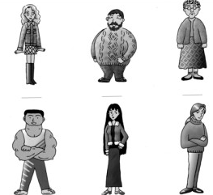

*Now use the vocabulary you learned to describe the people below.

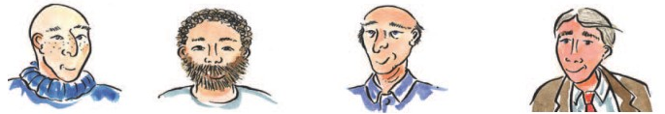

He’s ________ and  has _________. | He has a _______ and a ___________ | He has receding hair and a few _________. | His hair’s gone ______.

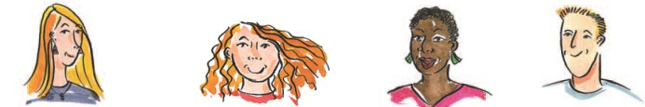
She has _________ hair  and she’s ______-faced. | She has ______ hair and she’s _________-faced. | She has _______ hair and is ______-skinned. | He has a ______-cut.

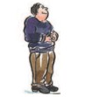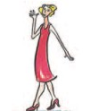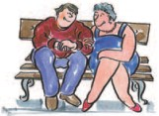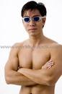
He’s rather _______. | She is _____(positive)  She is ______ (rather negative) | They are an _____ couple (negative) | He’s _______-built.

Fashion Items
- Clothing Mind Map
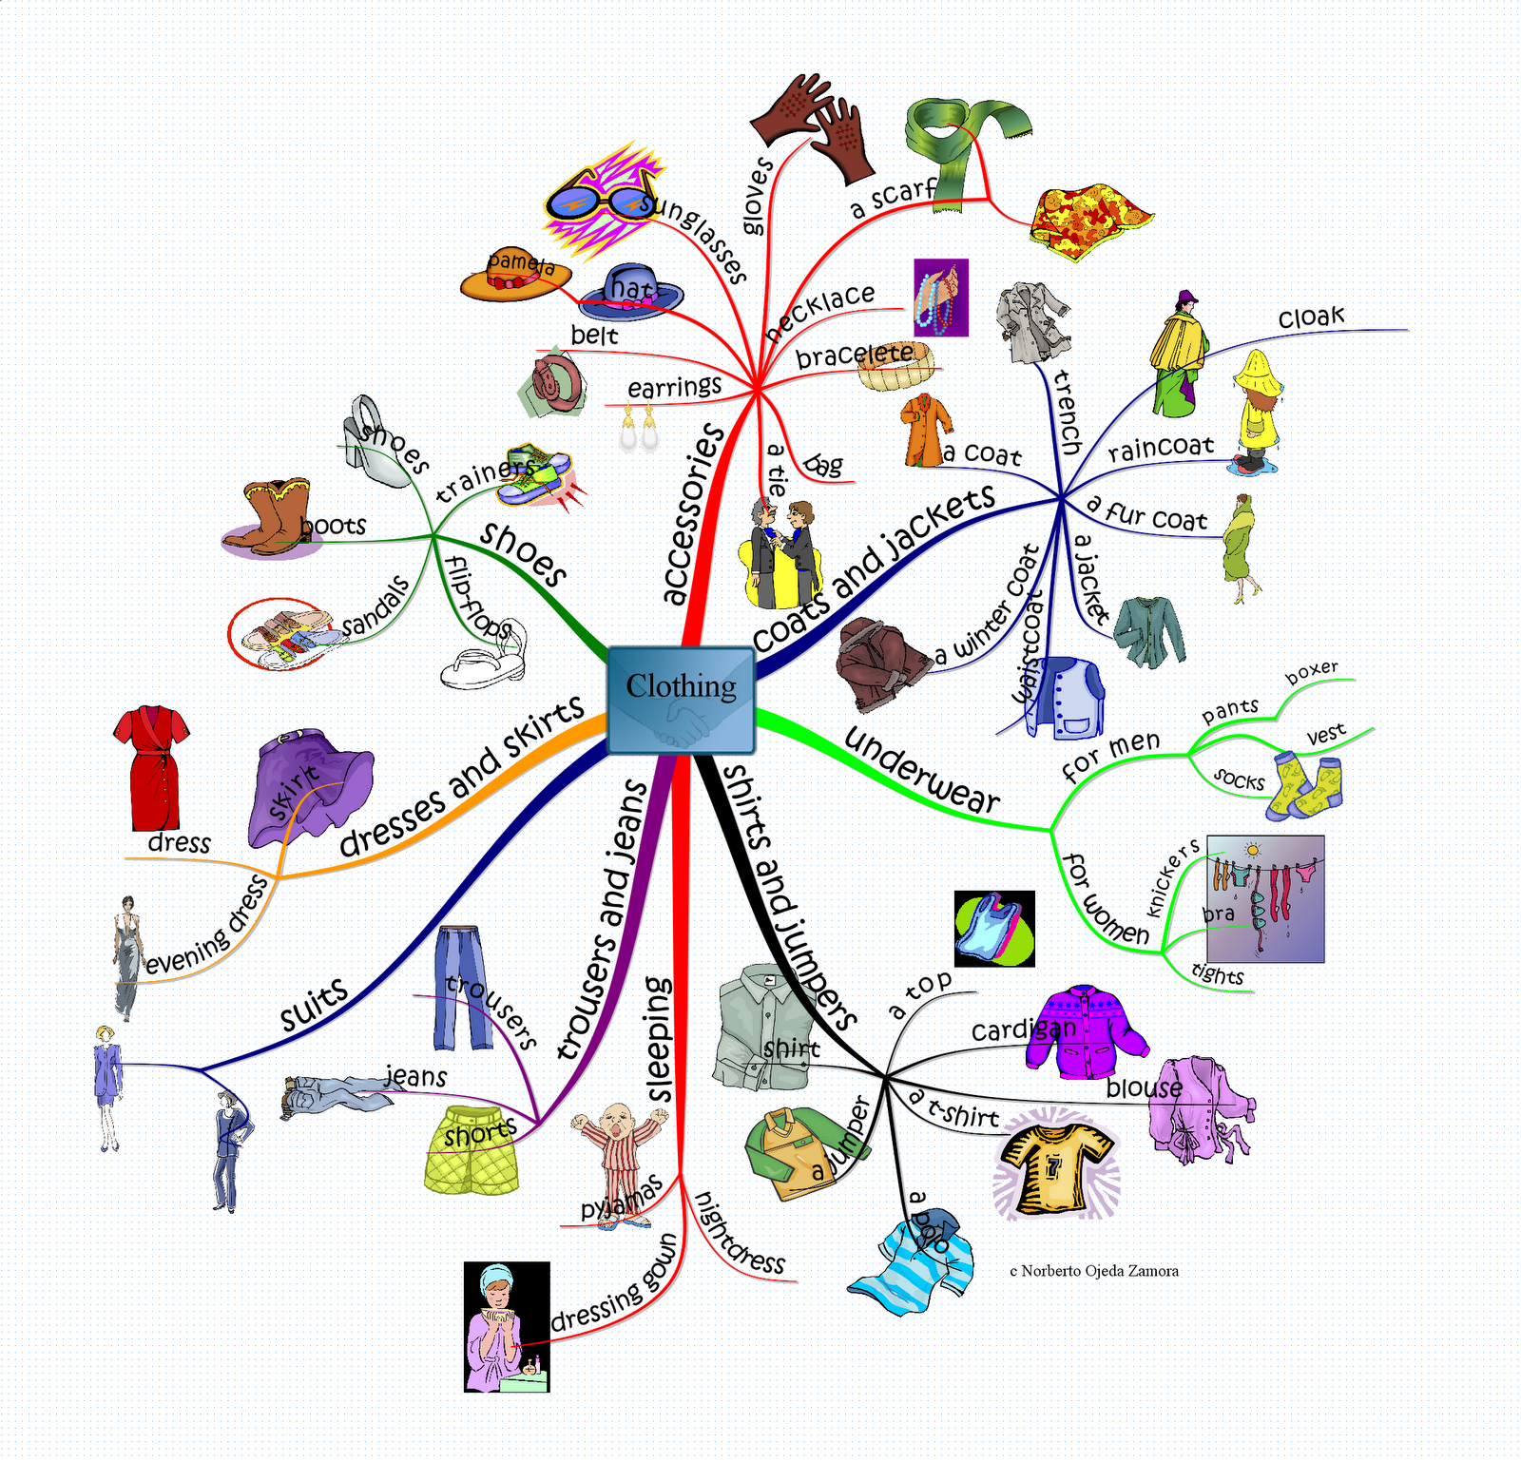

- Clothing Vocabulary with pictures
Uni-Sex | Women’s Clothes  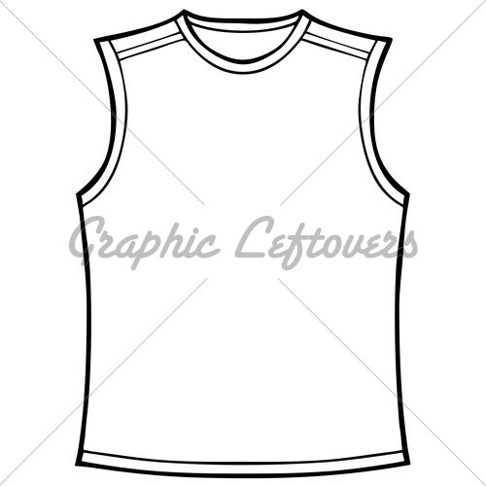  sleeveless
Footwear  flip-flops | Men’s Clothes
Accessories & Jewellery | Underwear  pantyhose
Parts of Clothes

- Word Puzzle
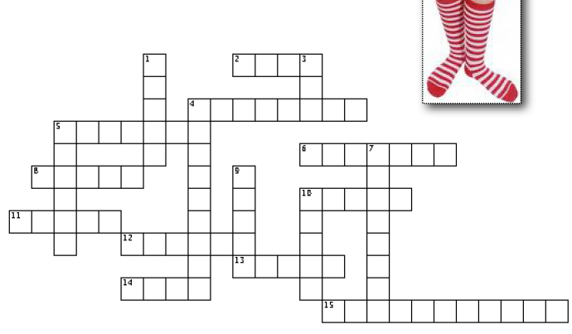
Across  2. Something you wear in winter, to keep you warm.  4. Men wear them on their legs.(British English)  5. You wear it to keep the top half of your body warm in winter.  6. When you enter a Japanese house, you should t__ o_ your shoes.(Two words)  8. You wear them on your feet.  10. It can have long sleeves, or short sleeves.  11. In the morning, you ____ _____ your clothes.(Two words)  12. A kind of shirt, for woman.  13. You wear it around your neck in winter.  14. You wear it to hold up your trousers.  15. Young men often wear one on their head, backwards.(Two words) | 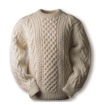  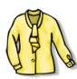  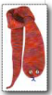 | Down  1. Men wear them on their legs. (American English)  3. You wear it around your neck.  4. You wear it when you are training.(Two words)  5. You wear them in summer, to keep your legs cool.  7. Jewelry. You usually wear two of them.  9. You wear them on your feet. 10. The bottom half of a girl’s school uniform. | 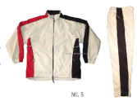

4. Fabric & Patterns
1) Fabric: silk, cotton, velvet, corduroy, denim, leather, wool, suede, rayon, nylon, spandex,
twill, tweed
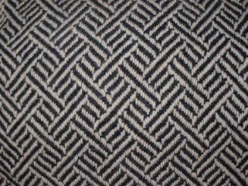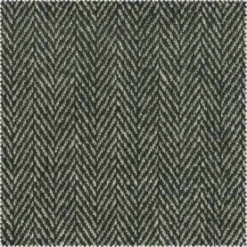
2) Patterns: checkered, solid, paisley, striped, plaid, polka-dotted
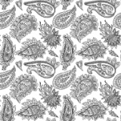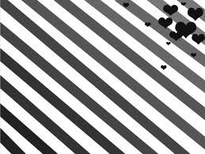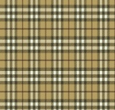

*What are they wearing?
A B C D E
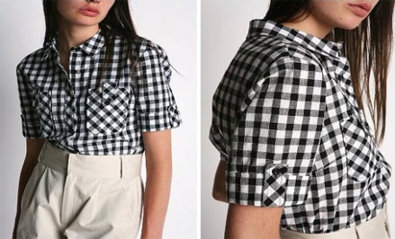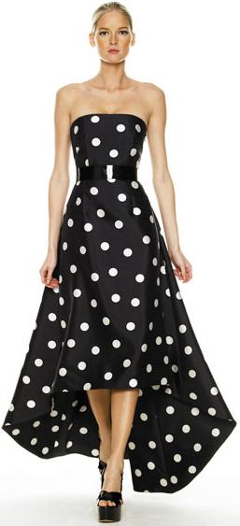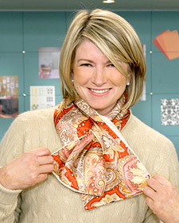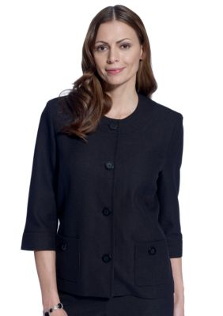
A She is wearing a red __________ skirt.
B She is weaking a ___________, short-sleeved shirt.
C She is wearing a ____________, sleeveless dress.
D She is wearing a ___________ scarf.
E She is wearing a black _______ jacket.

