Week 10 Reading Assignment

Student Number: ___________________ Name:_____________________

Paragraphs to Describe Graphs and Charts

You will use information and facts presented in charts and graphs to support the topic sentence of the paragraph. Often, the data presented in a graph or table show change over time. There are specific verbs and adverbs that can help you describe these changes

Lesson 1: Verbs for describing how data have changed

 |  |  |  |  | 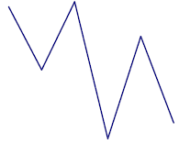
• to increase  • to go up  • to rise  • to climb  - to jump  - to grow  - to expand  - to boom  - to recover  - to improve | - to (sky)rocket  - to sore | - to remain (unchanged)  - to be steady  - to remain  - to stay the same  - to maintain  - to hold  - to keep  - to continue  - to flatten out  - to level off  - to stabilize | - to decrease  - to go down  - to decline  - to drop  - to fall  - to go down  - to lose  - to loss  - to shrink  - to get worse  - to reduce | - to plunge  - to plummet  - to collapse | - to fluctuate

Exercise 1: Categorize the verbs
increase  fall  decrease  climb  drop  decline  lift  rise | GO UP GO DOWN  increase decrease  ______________ ______________  ______________ ______________  ______________ ______________  ______________ ______________  ______________ ______________

Lesson 2: Adjectives and Adverbs to describe how fast the change occurred
 |  | No change | For big, sudden or  unexpected changes
Focusing on  regular movement | Focusing on  small changes | No change | For big, sudden or  unexpected changes
gradually  steadily  continually  regularly  slowly | slightly  faintly | remain steady  remain constant | sharply  dramatically  suddenly  significantly  severely  extremely  markedly  considerably  rapidly  quickly
Exercise 2: Label the lines with the words below

①remain steady  ②fluctuate  ③increase slightly  ④decrease dramatically  ⑤decrease slightly  ⑥increase rapidly  ⑦rise dramatically  ⑧plunge  ⑨drop suddenly  ⑩stay the same  ⑪go up a little  ⑫go down slightly | 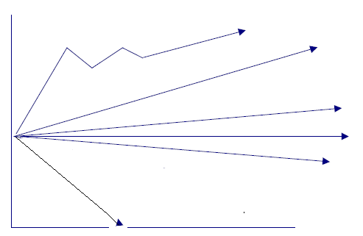

Exercise 3: In the column on the left, there are nine graphs (A- I). Opposite each graph, you have four statements which describe each graph. Decide which statement is correct in each case and circle it. There may be more than one answer.

A   | i. The trend in customer numbers was upward.  ii. Customer numbers fluctuated slightly.  iii. There were considerable fluctuations in customer numbers.  iv. There were fluctuations in customer numbers.
C | i. The trend in customer numbers was upward.  ii. Customer numbers fluctuated wildly.  iii. There was a downward trend in customer numbers.  iv. Customer numbers were erratic.
B  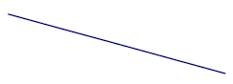 | i. The number of customers fell dramatically  ii. Customer numbers fell.  iii. Numbers fell steadily.  iv. There was a dramatic drop in customer numbers.
E  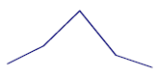 | i. The trend in customer numbers was upward.  ii. Customer numbers hit a peak.  iii. There was a peak in customer numbers.  iv. There was a slight dip in customer numbers.
G  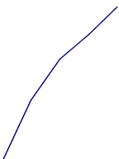 | i. Customer numbers soared.  ii. Customer numbers rocketed.  iii. There was a steep rise in customer numbers.  iv. There was a gradual rise in customer numbers.
H  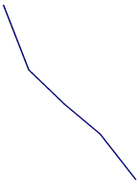 | i. There was a steady fall in customer numbers.  ii. Customer numbers fluctuated.  iii. Customer numbers plunged.  iv. The trend was flat.
I | i. There was a slight dip in customer numbers.  ii. The trend in customer numbers was upward.  iii. Customer numbers dipped.  iv. Customer numbers reached a peak.

Exercise 4: Look at the graph and fill in the blanks in the report on CD sales at JJ Mart discount stores. Fill in the blanks using the words in the box.
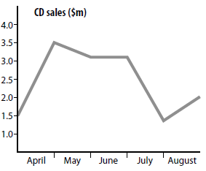

rose slightly
rose sharply
remained constant
fell slightly
fell sharply

CD sales were very uneven last year. In April sales ______________from $1.5 million to $3.5 million. In May they _____________ to just over $ 3 million. In June sales _____________ but ___________ in July to just under $ 1.5 million. In August they ______________________.

Exercise 5: Now use the graph below to write a short report on footwear sales. Use the report in Exercise 6 to help you.

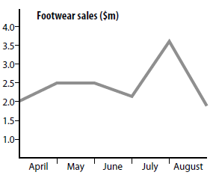
Foot sales fluctuated wildly last year. In April
------------------------------------------------------------------------

------------------------------------------------------------------------
In May
------------------------------------------------------------------------

-------------------------------------------------------------------------
In June
-------------------------------------------------------------------------

----------------------------------------------------------------------------------------------------------------------
In July
----------------------------------------------------------------------------------------------------------------------
In August
----------------------------------------------------------------------------------------------------------------------
In the future, foot sales will decrease continuously.
----------------------------------------------------------------------------------------------------------------------

Lesson 3: Using preposition
- from  - to  - during  - between  - at  - of  - by  - over  - in | - From 2004 to 2008 imports rose.  - Between March and July inflation decreased sharply.  - By 4:00 pm 90% of the stations are crowded.  - During the peak hours the connection speed falls.  - over the last(next) ten year  - In the 1990s, oil was the most popular fuel.  - For middle school students, the time spent reading in 2000 fell between 3 and 4 hours per week.  - It starts out at 70% in 1994.
Exercise 6: Read this information about the company and use it to complete the graph below.

The company’s net income increased from 1988 to 1997. However, growth was uneven and was greatly affected by the Turkish economy. After slow growth at the end of the 1980s, there was a large increase in 1990, but the following year income fell again. In 1992 there was a large increase to $320 million. Income rose sharply by $216 million to $538 million in 1993. In 1994 income fell to $330 million, but rose again by $95 million in 1995. There was a slight increase in 1996 to $438 million, but then income fell sharply by $281 million in 1997, finishing at $157 million. However, prospects in the next few years are good for Turkey’s largest industrial company.
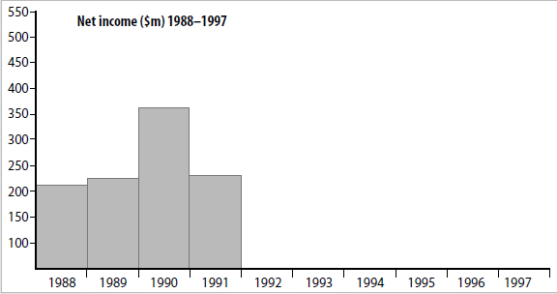



Lesson 4 and Exercise 7: How to analyze a graph

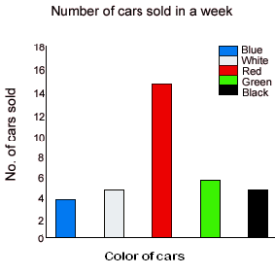
Analyze the graph by answering the questions.

1. The title of this graph is. ___________________________.
2.The horizontal axis shows __________________________.
3.The vertical axis shows ____________________________.
4.Which color of car sold the most? ____________________.
5.How many blue cars were sold? ______________________.
6.Which two color of cars sold the same amount? _________.
7.describe how data have changed.(Lesson 1 ~3)

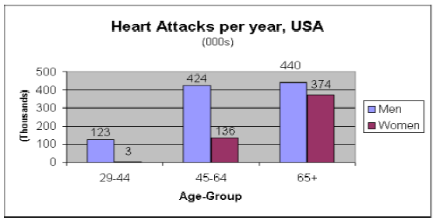
Lesson5: Linking words: however, while, compared with, whereas
Example 1: However
The graph shows how age and gender influence the frequency of heart attacks in the US.
-------------------------omission----------------------
Over the age of 65, the number of men suffering heart attacks only increases slightly. However there is a huge increase in the number of women with heart attacks. They comprise over 40% of all victims.
-------------------------omission----------------------
In conclusion, men are more likely to be the victims of heart attacks at all ages, but
women are increasingly likely over the age of 65.

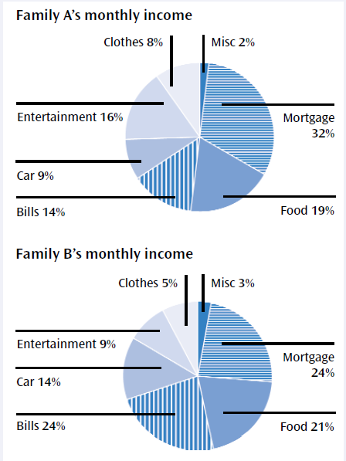
Example 2: while

In general, Family B spends more on necessary items such as bills, food and their car, while Family A allows slightly more money for entertainment and clothes.

Example 3: compared with & whereas

Air pollution level gradually increased in December compared with October. The ozone layer has been steadily decreasing especially during the summer. Ninety percent of American people seem to have their own cars, whereas sixty percent of Korean do.

Lesson 6: Organization

It’s challenging to describe not in sentence level but in paragraph.

Introduction | The (type of graph) shows…  It’s about ….  The topic(subject) is about …...  According to this picture(chart), …..  If(as) we look at this graph, we see that …
Body | First, Next, Then, After that, The next point is, also, Finally
Conclusion | In conclusion, we can predict that ….. will ……….  To sum up, the number of ……… will be ………ing continuously.  In the future, ………. will be used generally.  In the future, ……….. will be more ……. than ………….

Exercise 8: [Double Line Graph] Write the introduction and conclusion of the article. Chunks Bank will be helpful.
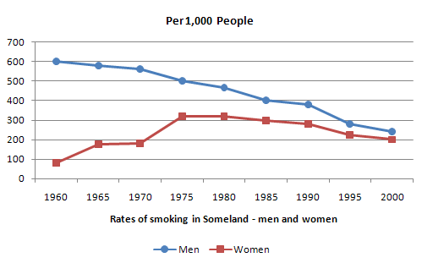
----------------------------------------------------------------------------------------------------------------------

----------------------------------------------------------------------------------------------------------------------

----------------------------------------------------------------------------------------------------------------------

----------------------------------------------------------------------------------------------------------------------

----------------------------------------------------------------------------------------------------------------------

Chunks Bank
between the years 1960 and 2000 the rate of smoking throughout the period.
for both men and women in Someland The graph shows…

In 1960, 600 men in every 1,000 was smoking. This number decreased gradually to 500 by 1974 and continued to decrease but more steeply to 250 in 2000. In contrast, the rate of smoking in women in 1960 was very low at only 80 in every 1,000. By 1968 this increased to 170, and increased again but more steeply to 320 in 1977. The rate of female smokers then remained stable at 320 until 1984 at which point the figures began to decline and had dropped to 200 by 2000.

----------------------------------------------------------------------------------------------------------------------

----------------------------------------------------------------------------------------------------------------------

----------------------------------------------------------------------------------------------------------------------

----------------------------------------------------------------------------------------------------------------------

----------------------------------------------------------------------------------------------------------------------

Chunks Bank
In conclusion the rate of smoking in men throughout the whole period
at a higher level than for the rest of the period . until 1977

Student number: Name:

Write 10 expressions that you think the most useful from the reading.
*Please leave this column
1
2
3
4
5
6
7
8
9
10

What other expressions did you use? (They include the expressions of week1 through week6)
(*We’re going to do this after the class)

Fun-fun egg dying & decorating

Please read all instructions before coming to class.



Coloring
- Start with clean, cool, hard-boiled eggs.
- Add a dye tablet and 3 tablespoons of water to a cup container, the gently stir.
- Choose desired crayon color. Draw on egg to create your own design.
- Gently place egg in color bath until desired color appears on the egg. The longer the egg stays in the bath, the darker the color will be.
- Remove egg, drain will, and place it in drying tray and let dry.

You can also check the following website for more information.
http://www.wikihow.com/Dye-Eggs-for-Easter

