Week 11 Reading Assignment
Name:__________________________

Useful Expressions when giving opinions

Giving Opinions
- I agree/ disagree (=don’t agree) with you.
I agree entirely/ totally. I agree with her opinion a hundred percent.
I’m not sure/I’m afraid I can’t agree with her.
- I would like to give you an example to help you understand my point.
E.g.) I don’t think getting plastic surgery is completely correct for the following points.
A. first, firstly, first of all, in the first part
B. second, secondly, then, next
C. third, thirdly, and then
D. also
E. in addition ~
F. besides
G. finally, lastly, last of all

Other useful chunks with examples
- Chunks to be used in the introduction
I think/feel/believe/hope/imagine/understand/suppose/realize that ~
I’m all in favor of ~, I’m in total agreement with, I have same opinion as,
I’m of the same opinion~, I agree but, Could be but, I’d accept that but,
I agree in principle but
I’m afraid I can’t accept, I disagree entirely that

- Chunks to be used in the body
What I mean is that~
It is my opinion that, in my opinion, I think(believe), It seems to me that, It appears that, to my mind, from my point of view, in my view, to me, to my way of thinking, according to me, as far as I’m concerned, as I see it

- Chunks to be used in the conclusion
Finally, Lastly, To conclude, In conclusion, As I said before, In short, In other words, To sum up, In summary, What I’m trying to say is, In a nutshell, On the whole, Most important~, As the result of this(these)

Agree with vs. agree to vs. agree on

You use 'agree with' when you agree with something another person has said.
You use 'agree to' when you agree to do something.
You use 'agree on' when both parties are in agreement on a certain topic.
Agree with: If a situation or new conditions agree with you, they make you feel healthy and happy
You look well - the mountain air must agree with you.

Agree to: to agree something
Both sides in the conflict have agreed to the terms of the peace treaty.

Agree on: to agree on a subject
World Leaders agree on using military force in Libya

Job Application Process
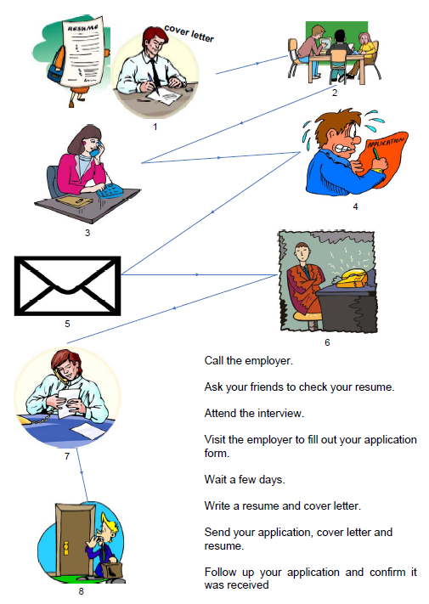

Write sentences under each picture describing each step of the process.

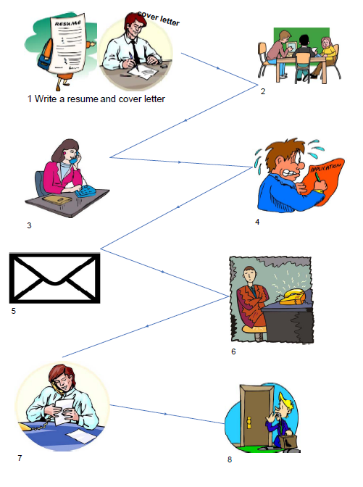
Please read this job advertisement and then answer the following questions.
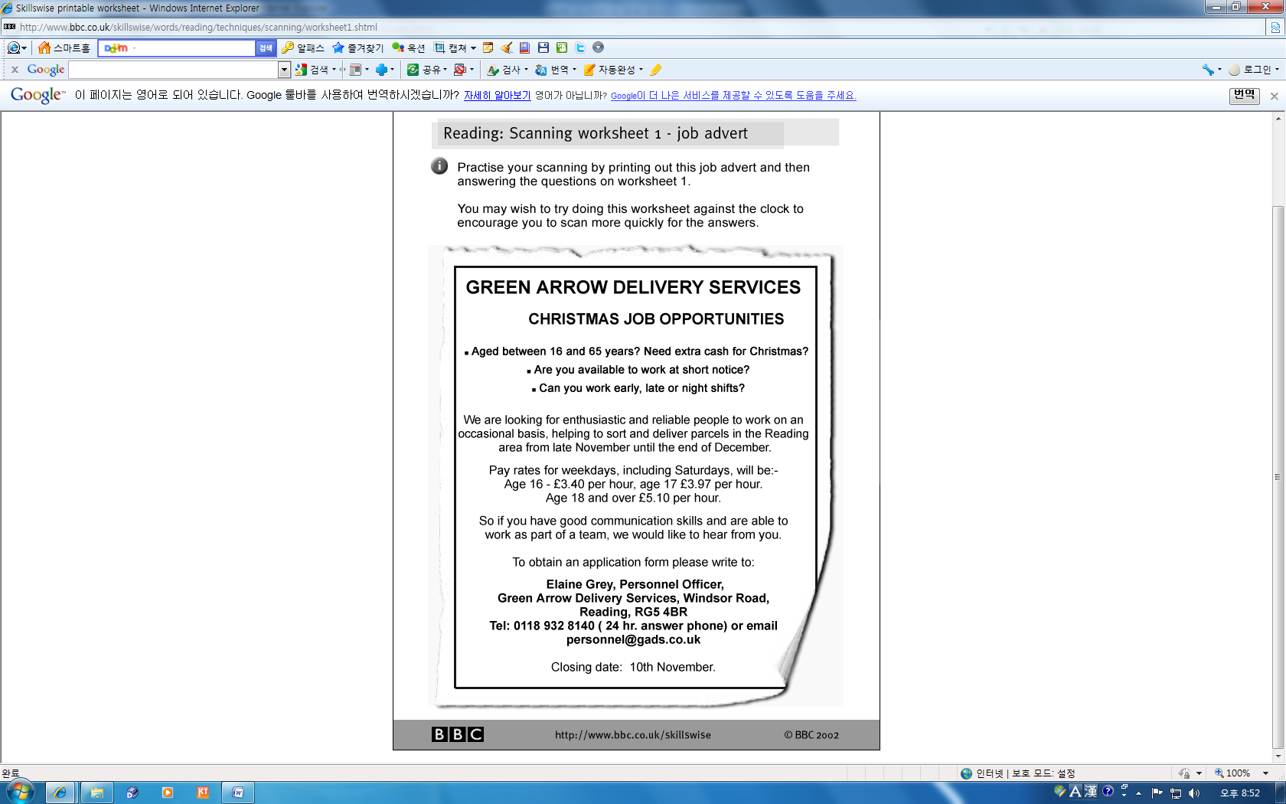

Reading Comprehension Questions

Read the job advertisement above, underline some useful lexical chunks directly on the page.

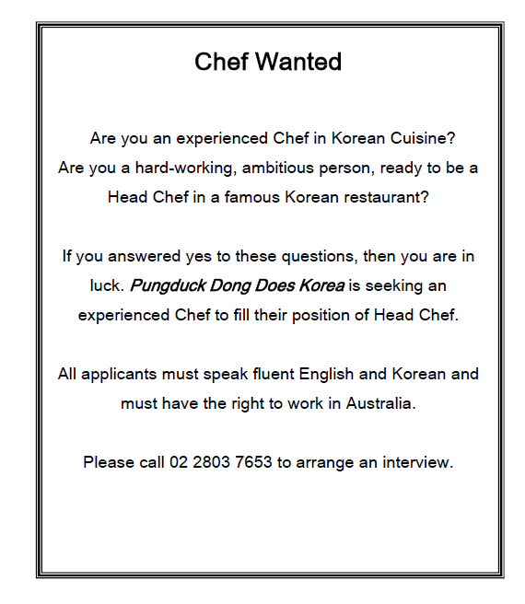
Employer
You are the owner of a Korean Restaurant in Sydney. You need to employ an experienced Korean Head Chef to work in your kitchen.

The prerequisites for this position are:
1) Must have at least 2 years’ experience as a chef because the person will be in charge of the kitchen.
2) Must speak fluent English and Korean.
3) Must have recognized training in preparing Korean food from a reputable cooking academy.
4) Must be looking for a long-term position.
5) Must be able to work in Australia.
Desirable qualities (preferred but not essential) are:
1) Should possess leadership qualities in character, experience in a leadership role desirable.
2) Should have experience working in a Korean restaurant.
3) Should be organized, efficient, punctual and hard-working.
4) Should be able to build good relationships with co-workers.

Jobseeker 1 (Male)
Your name is Tim Chung and you are an experienced Korean chef. You are 55 years old. You have been living in Sydney since you were ten and learnt to cook Korean food from your mother and then from the Sydney school of Korean Cuisine. You used to own your own Korean restaurant in Sydney's south side but you sold it, because you are getting older. You are hoping to retire in ten years. You speak English better than Korean but still speak Korean well. You are an Australian citizen.
Jobseeker 2 (Female)
Your name is Hanju Hwang and you are 30. You are Korean and are in Australia on a 2 year work visa. You are from Busan and worked in a Korean restaurant in Busan for ten years before you came over to Australia. You studied Korean Cuisine at the Seoul Centre for Culinary Arts. In the Korean restaurant, your job was Second Chef and you left the job because you want to be a Head Chef. You are hoping to get a job in Australia so you can extend your visa and move to Sydney permanently.
Jobseeker 3 (Male)
Your name is Peter McDonald and you are 35. You are a Canadian who has been fascinated with Korean food since teaching English in Korea. You learnt to cook Korean food formally at the Toronto College of Cuisine and have worked in a Korean restaurant in Toronto for 5 years. For 2 of the 5 years you were the Head Chef there. You left the job however, because you had an argument with the restaurant owner over the menu. You decided to move to Australia because it is warmer and you want to work here for at least a year. You’re not sure if you are going to move permanently yet. You speak English as a first language and studied Korean in Korea for two years.
Jobseeker 4 (Female)
Your name is Tina Kim and you are a college graduate from Korean Cuisine College of Melbourne. You are 24. You are ambitious and want to work as a Head Chef in a Korean restaurant but don't have experience. You worked at the Melbourne Casino whilst at College as a kitchen hand for two years. You are an Australian citizen but you were born in Korea. You have moved to Sydney from Melbourne with your boyfriend for his job. You speak fluent Korean and English. Your boss at the Casino praised your hard-work and dedication.
Jobseeker 5 (Male)
Your name is Jisun Lee and you are Korean. You are 37 years old and have married an Australian woman. You have moved to Australia permanently. In Korea, you worked at a restaurant called 'The Outback' which is how you met your wife. You worked as a head chef there for ten years and had good relationships with all of your co-workers. You speak fluent Korean but your English is still not very good. You are taking English as a Second Language classes at Sydney University and your wife helps you to study English. You studied Korean food at Daegu Food College and worked for two years in a Korean restaurant before getting the job as the Head Chef at 'The Outback'
Jobseeker 6 (Female)
Your name is Anna King. You are an Australian from Brisbane. You are 31 years old. You’ve loved Korean food ever since you tried it at age ten and studied at the Seoul Academy for Chefs when you were 22. You hope to open your own Korean restaurant one day but are still saving up the money. You worked as a Second Chef in a Korean restaurant for 5 years and then as a Head Chef in the same restaurant for 4 years. You left your job though when your husband and you decided to move to Sydney to buy a house together. You are now looking for a job to save money to buy your own Korean restaurant. You speak English well but Korean not so well. Still, you know all of the Korean food words perfectly and picked up a fair bit of Korean whilst studying in Seoul. You are willing to study Korean as a Second Language at Sydney University.

Your goal is to find the right person to be hired for the position. Who would you hire and why? (Answers may vary.)

Jobseeker:

Reason:

Prerequisite: required or necessary as a prior condition

Ex) A visa is still a prerequisite for travel in many countries.

Reputable: having a good reputation; honored, trustworthy, or respectable

Ex) The purpose of attending a competitive college is to learn from reputable professors

Punctual: having the characteristic of always keeping to arranged times, as for appointments, meetings etc

Ex) She is always so punctual in terms of arriving at the classroom.

What motivates you at work

Studies of successful individuals have found that there tends to be a few motivators that consistently guide their career and job choices, and make working an enjoyable and ultimately successful experience for them.

Read through the list given below of ten work motivators.

What motivates you? | Description
Challenge | You like to engage in demanding and complex tasks, and to have challenge, variety, novelty and obstacles to overcome in your job
Competence | You like to make full use of your knowledge, skills & abilities, and to be an authority in your area of expertise
Independence | You like to be as free as possible from restrictions and rules while doing your job, to organize your own work and be accountable for your actions
Interest | You like to do work that is interesting to you, and which gives you the opportunity to learn and improve your skills
Lifestyle integration | You like to take into account all aspects of your life when choosing your ideal role
Money | Pay and other material rewards are important to you, and you want to do a job that will allow you to earn a lot of money
Recognition | You like to get positive feedback and public credit for work well done, and to be respected for your abilities
Relationships | You like to get on well with colleagues and to work in a supportive, sociable environment
Security | You want to have a reasonable guarantee of a stable future, with continued employment and a regular income
Variety | You like variety rather than repetition in your daily routine, and a job that develops over time

Please complete the sentences with the ten motivators above.

- Ella complained that the company never gave her any ________________ for her work.
- Finding a solution to this problem is one of the greatest ________________ faced by scientists today.
- He reached a reasonable level of __________________ in his English.
- It's important that parents should allow their children some ______________________.
- I've always had an _______________ in astronomy.
- ___________________ is very difficult to achieve with a society whose culture is so different from your own.
- Scientists have established the _________________ between lung cancer and smoking.
- The tighter ______________________ measures/precautions include video cameras in the city centre.
- We invested the ___________________ in a high-interest bank account.
- Work on the production line is monotonous and lacks _______________________.

Why mothers are ditching the nanny to hire a 'manny'

Would you hire a 'manny'?

By Alexandra Frean
From The Times
September 4, 2006

WORKING mothers are increasingly keen to hire a man to look after their children rather than bring a young, attractive female nanny into their homes, according to a childcare recruitment agency.

A survey of 1,500 families by the agency, Tinies, suggests that attitudes are changing towards male nannies — or “mannies”, as they are known.
Eight out of ten parents said that it was more acceptable now than ten years ago to hire a male nanny, while 94 per cent said that they would consider hiring a man for the job.
A fifth said that they knew of a family who already had a male nanny.
However, only 4 per cent of people working in the childcare industry are men. There are about 12,500 men registered as childcarers — up from 8,500 in 2003.

Oliver Black, the agency’s director, said that female insecurity, jealousy and mistrust were key factors in the change. “Our research shows that the threat of an attractive female nanny is certainly an issue,” he said.
Working fathers, however, were far less concerned by the thought of hiring an attractive male nanny, possibly because they believed that a man who worked with children would not be a threat.
However, despite their popularity mannies are in short supply because few men consider going into childcare.
“Attitudes are certainly changing,” said Mr. Black. “Mothers, especially, are now more than happy to leave their children in the care of an experienced and qualified male childcarer.
“However, there are very few male nannies and nursery staff out there. The ones we have placed have always been a great success.”
Mr. Black said that it was very important to get the right person for the job, whether male or female.
“Qualifications, references, a criminal records check, experience and a face-to-face interview are crucial in appointing a quality nanny.”
Experts have long called for more men to work in childcare, arguing that children would benefit from exposure to a wider range of positive role models.
For the child of a single mother, for example, a male carer may be the only male role model in his or her early years.
However, many men are deterred by the low pay, poor terms and conditions, lack of career progression and the perception that childcare is “women’s work”.
The Government has been trying to widen the pool of talent entering childcare, fearing that without more men its plans to expand childcare — including the ambitious extended schools programme — might fail.
A spokeswoman for the Department for Education said: “We believe that male workers have a lot to offer children, including acting as positive role models.
“We provide local authorities with money to recruit and train childcare workers, including £14 million for recruitment in 2004-06, and our childcare recruitment campaign has used a range of initiatives to target under-represented groups, including men.”

Definition
- Ditch
If you ditch something that you have or are responsible for, you abandon it or get rid of it, because you no longer want it.
She ditched her boyfriend because of his excessive dependence on his parents.
- Insecurity
Insecure people have little confidence and are uncertain about their own abilities and about whether other people really like them
I wonder what it was about her upbringing that made her so insecure.
- Threat
a suggestion that something unpleasant or violent will happen, especially if a particular action or order is not followed
The threat of jail failed to deter him from petty crime.
- In short supply
when there is little of something available
Strawberries are in short supply at the moment.
- Despite
without taking any notice of or being influenced by; not prevented by
I still enjoyed the week despite the weather.
- Qualified
having finished a training course, or having particular skills, etc
Tim is now a qualified architect.
- Crucial
extremely important or necessary
a crucial decision/question
It is crucial that the problem is tackled immediately.
- Exposure
when someone experiences something or is affected by it because they are in a particular situation or place
You should always limit your exposure to the sun.
- Lack of
when something is not available or when there is not enough of it
Her only problem is lack of confidence.
If he fails it won't be for/through lack of effort (= he has certainly tried).
We won't be going on holiday this year - lack of funds, I'm afraid.
- Deterred
to prevent from doing something or to make someone less enthusiastic about doing something by making it difficult for them to do it or by threatening bad results if they do it
These measures are designed to deter an enemy attack.
- Offer
to ask someone if they would like to have something or if they would like you to do something
I feel bad that I didn't offer them any food/offer any food to them.
Can I offer you (= Would you like) a drink?

Use these words below to complete the sentences.

Insecure, threat, in short supply, despite, qualified, exposure, lack of, deterring,
offered, crucial, ditch

- _____________ repeated assurances that the product is safe, many people have stopped buying it.
- Drunken drivers pose a serious ____________ (= cause a lot of harm) to other road users.
- Even a brief _____________ to radiation is very dangerous.
- He still feels _____________ about his ability to do the job.
- Her work has been ________________ to the project's success.
- High prices are __________________ many young people from buying houses.
- _______________ sleep had made him irritable.
- She was ______________ a job in Paris.
- Skilled labor will be _____________________.
- What makes you think that you are ________________ for this job?
- Why do you think he his girl friend?

Student number: Name:

Write 10 expressions that you think the most useful from the reading.
*Please leave this column
1
2
3
4
5
6
7
8
9
10

What other expressions did you use? (They include the expressions of week1 through week6)
(*We’re going to do this after the class)

